


Capital University

Faculty of Computers & Artificial Intelligence

Software Engineering Department

Alumni Portal : A Bridge Between

The University And its Graduates

A Graduation Project Dissertation By

Malak Mohammed Hemdan Ahmed
Moha

20225238

Ahmed ashraf ahmed ali sayed ahmed qandil

20225105

Yara Ashraf Mohammed Ibraheem

20225253

Ganna Tawfik Mo
ha
med Tawfik

20210253

Fatema Al
-
Zahraa Ghareib Mohamed

20210663

Mirna Nabil Helmy Rizk

20210982

Submitted in partial fulfillment of the requirements for the
degree of

Bachelor of Science in Computers & Artificial
Intelligence at the Software Engineering Department
,
Faculty
of Computers & Artificial Intelligence
–

Capital University

Supervised By

Dr. Helal Ahmed

Suleiman

June 2026



Helwan University
Faculty of Computers & Artificial Intelligence Software Engineering Department

Alumni Portal : A Bridge Between

the University and its Graguates

A Graduation Project Dissertation By
Malak Mohammed Hemdan Ahmed 20225238
Ahmed Ashraf Ahmed Ali Sayed Ahmed Qandil 20225105
Yara Ashraf Mohammed Ibraheem 20225253
Ganna Tawfik Mohamed Tawfik 20210253
Fatema Al-Zahraa Ghareib Mohamed 20210663

Submitted in partial fulfillment of the requirements for the degree of Bachelor of Science in Computers & Artificial
Intelligence at the Software Engineering Department, Faculty of Computers & Artificial Intelligence – Capital University

Supervised By
Dr. Helal Ahmed Suleiman

Computers & Artificial Intelligence, at the Information Systems Department, the Faculty of
Computers & Artificial Intelligence, Helwan University
Supervised by:
[ Dr. Helal Ahmed]
January 2025



Faculty of Computer and Artificial Intelligence Helwan University.

Information System Department.

Supervised By:

DR. Helal Ahmed

Acknowledgement

We would like to express our deepest gratitude to everyone who supported us throughout the development of our graduation project, “Alumni Portal”.
First and foremost, we would like to sincerely thank our supervisor, Dr. Helal Ahmed, for his continuous guidance, valuable feedback, and encouragement throughout every stage of this project. His experience and support helped us overcome many challenges and improve the quality of our work.
We also extend our appreciation to the Faculty of Computers and Information Technology at Capital University, especially the Software Engineering Department, for providing us with the academic knowledge, resources, and supportive environment that enabled us to successfully complete this project.
Our project, “Alumni Portal,” was developed to strengthen communication between graduates, and the university community through a modern digital platform. The system includes features such as alumni networking, real-time chatting, job and internship opportunities, event announcements, document request management, and AI-powered content moderation to ensure a safe and professional environment for all users.
Special thanks to the open-source community and the developers of the technologies that contributed to building our system, including React.js, Node.js, Express.js, Socket.IO, PostgreSQL, and AI moderation services, which helped us create a scalable and efficient platform.
We would also like to thank our families and friends for their patience, encouragement, and emotional support during stressful times and deadlines. Their motivation gave us the strength to continue and achieve our goals.
Finally, we would like to thank each other as a team for the dedication, cooperation, and countless hours of hard work invested in this project. From solving technical challenges to preparing presentations and documentation, this journey strengthened our teamwork skills and transformed this project into an achievement we are truly proud of.

Abstract
The “Alumni Portal” project is a web-based platform designed to strengthen communication and collaboration between graduates and university administrators through a centralized digital system. Many universities face challenges in maintaining long-term engagement with alumni with access to professional guidance, career opportunities, and alumni networks. Our project addresses these challenges by creating an interactive platform that connects all members of the university community in one secure and efficient environment.
The system provides multiple features including alumni networking, real-time chatting, post sharing, event announcements, job and internship opportunities, and document request management. The platform also includes role-based access control for administrators, alumni, students, and alumni affairs officers to ensure organized system management and secure access to resources.
To improve platform safety and user experience, the system integrates AI-powered content moderation techniques to detect inappropriate or harmful content before it is published. In addition, the real-time communication system enables users to interact instantly and build stronger professional and academic connections.
The project was developed using modern web technologies including React.js for the frontend, Node.js and Express.js for the backend, PostgreSQL for database management, and Socket.IO for real-time communication features. The system was designed with scalability, security, and usability in mind to ensure reliable performance for a large number of users.
This documentation presents the analysis, design, implementation, and testing processes of the Alumni Portal system. It also demonstrates how modern web technologies and AI-based solutions can be combined to create an effective digital platform that enhances alumni engagement, supports students’ career development, and strengthens the relationship between universities and their graduates.

Table of content:
Acknowledgement...................................................................4
Abstract....................................................................................4
Chapter 1: Introduction...........................................................9
1.1 Overview……………………………………………………………………………….10
1.2 Objectives………………………………………………………………………………11
1.3 Purpose………………………………………………………………………………….13
1.4 Scope…………………………………………………………………………………….13
1.5 General Constraints……………………………………………………………….16
Chapter 2: Planning & Analysis…………………………………………..14
2.1 Project Planning……………………………………………………………………..15
2.1.1 Feasibility……………………………………………………………………..15
2.1.2 Estimated Cost………………………………………………………………18
2.1.3 Gantt Chart…………………………………………………………………..18
2.2 Analysis & Limitation of Existing System…………………………………19
2.3 Need for the New System……………………………………....................21
2.4 Analysis of the New System…………………………………....................22
2.4.1 User Requirements……………………………………………………….22
2.4.2 System Requirements…………………………………...................25
2.4.3 Domain Requirements………………………………………………….25
2.4.4 Functional Requirements………………………………………………27
2.4.5 Non-Functional Requirements………………………………….....30
2.5 Advantages of the New System……………………………………………...33
2.6 Risk & Risk Managements……………………………………………………….34
Chapter 3: System Design………………………………..…………………36
3.1 Class Diagram………………………………………………............................37
3.2 Entity Relationship Diagram (ERD)…………………………..................38
3.3 Use Case Diagram…………………………………………………………………..39
3.4 Sequence Diagram………………………………………………………………….40
3.5 Activity Diagram……………………………………………………………………..41
3.5.1 Buying a Product…..………………………………………………………41
3.5.2 Going through the Marketplace……………………………………42
3.5.3 Vendor Dashboard…..……………………………………………………43
3.5.4 Admin Dashboard…………………………………………………………44
Chapter 4: System Implementation & Results…………….........45
4.1 Client-Side Architecture………………………………………………………….46
4.2 Server-Side Architecture…………………………………………………………49
4.3 Recommendation System……………………………………………………….53 4.4 Pseudocode …………………………………….…………………………………….55
Chapter 5: Testing………………………………………………………………71
5.1 Test Cases……………………………………………………............................72
5.2 Bug Reports…………………………………………………………………………….73
Chapter 6: Results………………………………………………………………75
6.1 Results……………………………………………………………………………………76
6.1.1 Expected Results…………………………………………………………..76 6.1.2 Actual Results……………………………………………………………….77
Chapter 7: Future Work……………………………………………………..88 Bibliography……………………………………………….........................90

Chapter 1

Introduction

1.1 Overview

Alumni Portal is a web-based platform designed specifically to connect university graduates in one centralized system. The platform enables alumni to communicate, share experiences, and build professional relationships after graduation. It also provides features such as real-time chatting, post sharing, job opportunities, and event announcements, creating an interactive and professional community for graduates. The system also serves as a centralized hub that brings all graduates together, making it easier for the university to access and engage with its alumni. This helps reduce the gap between the university and its graduates and strengthens the long-term relationship between them. The system aims to enhance continuous engagement and maintain a strong professional network after graduation.

1.2 Objectives

- To build a digital platform dedicated to university graduates.

- To enhance communication and networking between alumni.

- To provide job and career opportunities for graduates.

- To enable real-time communication through chat features.

- To strengthen the relationship between the university and its graduates by providing a centralized communication channel.

- To allow alumni to share posts, experiences, and achievements.

- To support administrators in managing the system efficiently.

- To ensure secure and reliable interaction using modern technologies.

1.3 Purpose

The purpose of this project is to develop a centralized system that facilitates continuous engagement between university graduates after completing their studies. Many graduates lose contact after graduation, making it difficult to maintain professional relationships or share opportunities. This platform solves this problem by offering a dedicated environment where alumni can stay connected, exchange knowledge, and support each other professionally.

1.4 Scope

- In the beginning, the project aims to create a centralized
platform that connects all university graduates in one system, making it easier for alumni to communicate and stay
connected
after graduation, as well as strengthening the relationship
between the university and its graduates.
2- The system will include multiple features and modules including:
- Alumni Profiles Management
- Real-time Chat System
- Posts and Interactions (likes, comments, feedback)
- Job and Internship Opportunities
- Event Announcements and Notifications
- Communities based on graduation batches and faculties
- Document Request System (e.g., graduation certificates
and official documents)
- Payment Integration for document requests
- Admin Dashboard for system management
- AI-based Content Moderation
3- After registration, alumni accounts must be verified against
the university database. If the graduate is not found in the
official database, the account cannot be activated unless it is approved manually by administrators or authorized staff
assigned by the system admin.
This ensures high-level security and protects the authenticity of university graduates.
4- Alumni can communicate through real-time chat, share posts, interact with each other, and participate in communities based
on their graduation batch or faculty. They can also explore job opportunities, share professional experiences, and engage in discussions within their community.
5- The system supports multiple stakeholders with different responsibilities:
- Super Admin: Has full control over the system, including monitoring all activities, managing employees, and
assigning permissions.
- Employees: Their access depends on permissions granted
by the Super Admin. Different employee roles include:
  - Managing posts and publishing official university announcements
  - Handling alumni document requests (such as
graduation certificates and official documents),
including approval or rejection
- Managing university services and collecting alumni feedback
  - Supervising communities and alumni activities
- Alumni: They are the main users of the system.
They can manage their profiles, create posts, interact with
others, join communities, send friend requests,
communicate
via chat, view university announcements, apply for document requests, make payments, and track request status.

1.5 General Constraints

Project constraints represent the general limitations that affect the development and performance of the Alumni Portal
system. These constraints include time, scope, cost, and data collection challenges.
• Time Constraint:
The time constraint refers to the limited schedule available for completing the project, including deadlines for each phase
such as analysis, design, implementation, testing, and final delivery of the system.
• Scope Constraint:
The scope of the Alumni Portal is limited to providing a centralized platform for university graduates only. The system includes features such as alumni networking, real-time communication, communities, document requests, and administrative management. Any functionality outside this defined scope is not included in the current version of the system.
• Cost Constraint:
The cost constraint refers to the financial limitations of the project, including hosting, development tools, and deployment resources. Since the project is academic, it relies mainly on
free and open-source technologies such as React.js, Node.js,
and PostgreSQL, minimizing overall cost.
• Data Collection Constraint:
Collecting accurate and reliable data was one of the challenges during system development, as access to real alumni data from the university database is restricted for privacy and security reasons. In addition, there was no fully structured or publicly available database to verify graduate information directly. Therefore, an additional internal data entry system was
designed for authorized employees to manually input and manage alumni records, which is then used to verify the
identity of graduates during registration and system access.
The system also depends on controlled datasets and verified records approved by authorized university staff. Additionally, designing realistic workflows for document requests, communities, and alumni interactions required careful analysis
to ensure correctness and consistency.

Chapter 2

Planning & Analysis

2.1 Project Planning
2.1.1 Feasibility Study

. Financial Feasibility

Being a web application DealHunt will have an associated hosting cost, bandwidth required for the operation of' this application is very low.

The system will follow the freeware software standards. Bug fixes and maintaining tasks will have an associated cost, At the initial stage the potential market space will be the local.

Also the web app will help vendors sell their items on the site and people buy these items from them with a percentage of the cost to the site will make the this web application feasible

From these it's clear that the project DealHunt is financially feasible

. Technical Feasibility

Project DealHunt is a complete web-based application. The main technologies and tools that are associated with DealHunt are

. HTML, CSS & Javascript
. React.js
. PHP Laravel

Each of the technologies are freely available and the technical skills required are manageable, Time limitations of the product development and the ease of implementing using these technologies are synchronized

Initially the web site will be hosted in a free web hosting space, but for later. Implementations it will be hosted in a paid web hosting space with a sufficient bandwidth required in (his application is very low)

From these it's clear that the project DealHunt is technically feasible

. Resource & Time Feasibility

Resource feasibility Resources that are required for the DealHunt project includes:

. Programming device (Laptop)
. Hosting space (freely online)
. Programming tools (freely available)
. Programming individuals

It's clear that the project DealHunt has the required resource feasibility.

. Social/Legal Feasibility

DealHunt uses freely available development tools and provides vendors with items to customers that can buy them, as for the legal feasibility DealHunt does not allow any kind of prohibited products to be sold on it

2.1.2 Estimated Cost

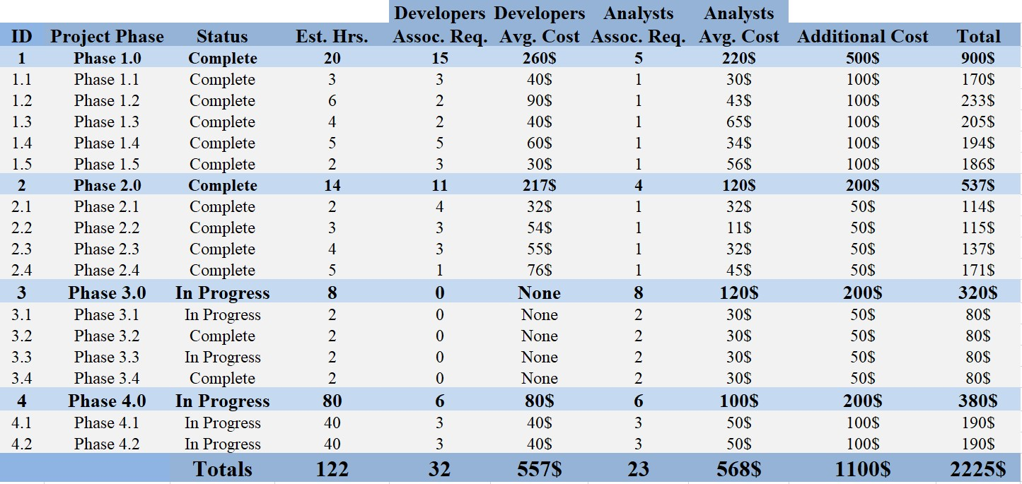

2.1.3 Gantt Chart

Chapter Name | Start Date | End Date | Duration
Chapter 1 | 01/02/2024 | 08/02/2024 | 7 Days
Chapter 2 | 09/02/2024 | 16/02/2024 | 7 Days
Chapter 3 | 17/02/2024 | 02/03/2024 | 14 Days
Chapter 4 | 03/03/2024 | 12/08/2024 | 162 Days
Chapter 5 | 13/08/2024 | 21/08/2024 | 8 Days
Chapter 6 | 22/08/2024 | 29/08/2024 | 7 Days
Chapter 7 | 30/08/2024 | 06/09/2024 | 7 Days

2.2 Analysis & Limitation of Existing System

The main limitations of the current system

The current system (Amazon or Dubizzle) suffers from a lot of limitations for example :

- Limited Regional Availability

- High Costs on Delivery

- Fake Reviews & Sellers

- Ad Scams & Listings

- No suggested price for item

- No swapping items

The things that make the current system operate slowly are:

. Too many steps to register

. Complex UI

. Weak Servers/Too many requests

. Bad Coding Structure

. Few payment options

. No tutorial for the website to new customers

. No recommendation of products to site

2.3 Need for the New System

Our new system applies the following features:

. Combining the power of old systems: where people can buy and trade online

. Swap is available: now you don’t have to order online only or sell & buy items only but you can do both and swapping items is also available

. Simple UI: our UI is simple and easy to use

. Recommendation of Products: Users now can see what items should they buy based on their purchase thanks to ML

2.4 Analysis of the new System

2.4.1 User Requirements

. This explains what the user will get through the site or application that you are using or the user what will it does inside the system?

. Often referred to as user needs, describe what the user does with the system, such as activities which users should be able to do. User requirements are generally documented in the User Requirements Document (URD) using narrative text. User requirements are signed in Generic by the user and used as the primary input for creating system requirements

. Our Sesame will consist of three types of users:

1- User (Customer)
This is the main user we made the site for where he can:

. Login/Register
. View Items on Products page
. Comment on Products
. Add Items to Cart and manage the Cart
. Choose Payment Method
. Checkout
. View Items on the Marketplace
. Add items to the Marketplace
. Edit/Delete his product on the Marketplace
. Manage his profile

2- Vendors

. Login/Register
. Upload Items on Products page
. Delete his own Products from Products page
. View Suggested Price of Products before adding them

3- Admins

. Login
. Manage Users/Vendors Accounts
. Ban Scammers
. Edit/Delete Products
. Edit/Delete Items from the Marketplace

2.4.2 System Requirements

This is considered the answer to the question - How will this system build? What software, hardware and network which will you work on?
. I mean, what is the software that I use for my son to appreciate this system?
. My data base is where I use it, for example, or where is it?
. What programming languages are used in my system?

2.4.3 Domain Requirements/ Business Requirements

This is what the business needs and will benefit from by making this application or this web site
. What benefited from the work of this system in terms of the system, I mean, I am now an example of the worker in a system for selling cars and to be able to achieve a certain goal, and this means.
. They agreed to integrate the objectives of the project with the objectives of the stakeholder
. Ensure that the BRD achieves a very wide and measurable set of process goals and that they meet customer requirements
. It will be adjustable and changeable
. Like you can write the BRD: You write "the name of the project and then "the goal you want to achieve" and then write "Why do you want to achieve this goal"

The “DealHunt” platform is an Ecommerce web application that is based on selling items from various vendors to users so users can buy them online also users can trade/swap items with each other on the Marketplace

2.4.4 Functional Requirements

- Registration:
. The User registers on the site entering his email, password, name and address
. The Vendor registers on the site entering his credentials as the user and also uploading his documents as a vendor

- Login as User:
. The User can view products on the products page
. The User can edit his profile
. The User can comment on Products
. The User can search a product by it’s category
. The User can view recommended produc

3- Login as Vendor
. The Vendor can add items to the products page entering its price, name and photo
. The Vendor can delete his items on the Products pag

4- Login as Admin

. The Admin can edit/delete items on Products Page or the Marketplace
. The Admin can ban scammers/users

5- Orderring a Product

. The User can view a product’s details
. The User can add the product to cart/remove it from cart
. The User can choose his payment method
. The User then checks out

6- Swapping Items

. The User can view products on the Marketplace which are uploaded by other users
. The User can add an item to the Marketplace by inserting it’s name, description, swap with money or item, photo and entering his phone number
. The User can edit/delete his items on the Marketplace

7- Banning Scammers

. Admins can ban scamming/toxic users
. Admins can ban vendors if they sell inappropriate content

2.4.5 Non-Functional Requirements

- Performance Requirements:

1-The system supports the use of multiple users at the same time.
- The database should be normalized to prevent redundant data and improve the performance.
- The database should be distributed to prevent outages. 4- We will make database backup several times.

2- Safety Requirements

The database may crash at any certain time due to virus or operating system failure. Therefore, it is required to take the database backup.

3- Security Requirements

- The system should be completely Consistent and Secure.
- Keep specific history data sets.
- Communication needs to be restricted when the application is validating the user.

4- Software Quality Attributes

The Quality of the System is maintained in such a way so that it can be very user friendly to all the users.
- Availability: Because this web site is critical to examination online process, we will have a goal of four nines (99.99%) availability.
- Correctness: The web site should never allow anyone to edit a profile not intended for that person.
- Maintainability: The web site should use continuous integration so that features and bug fixes can be deployed quickly without downtime.
- Usability: The interface should be easy to learn without a tutorial and allow users to accomplish their goals without errors.

The software quality attributes are assumed as under:
- Accurate and hence reliable.
- Secured.
- Fast speed.
- Compatibility

- Business Rules:

. The User can add items to Cart from the products page

. The user can manage his cart and checkout after choosing the payment option

. Swapping on the Marketplace is available for all users to add and trade items together

. Vendors add items to the Products page

. Admins can edit/delete products or items from the Marketplace

. Admins can ban scammers

2.5 Advantages of the New System

. The system presents the new SWAP feature to users on the Marketplace

. The system presents the add to cart option for products to be purchased online

. The system has a simple UI

. The system has a recommendation system for products introduced to customers

2.6 Risk & Risk Managements

Risks:

- Data Loss of Users Probability: Low

- Security problems may occur in the project when the correct data encryption method is not determined, and someone tries to penetrate the site
Probability: Low

- System crash due to undetected bugs & errors
Probability: Low

- Low numbers of users and vendors at launch
Probability: High

Risk Management:

1-Only authorized persons can access this data. Encrypt sensitive data to prevent big losses

- Do more than one security test and protect the server with the best protection available to preserve data.

- Testing the system regularly and testing it when adding a new update to identify and fix any errors or bugs before they become failures and crash the system.

- Find Sponsors to make ads about your site so many people start using it at launch time

Chapter 3

Software Design

3.1 Class Diagram

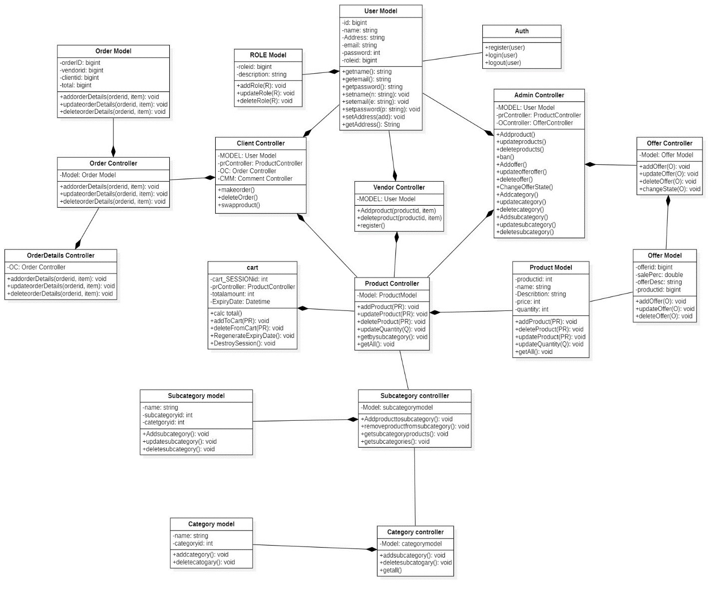

3.2 Entity Relationship Diagram (ERD)

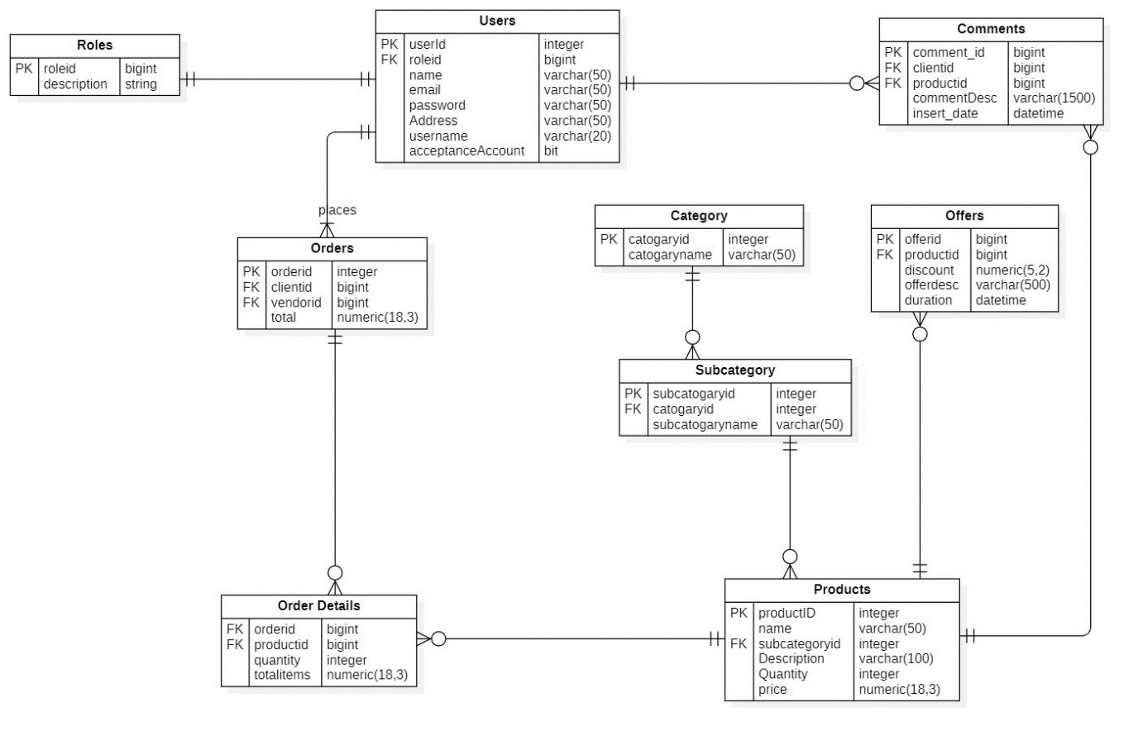

3.3 Use Case Diagram

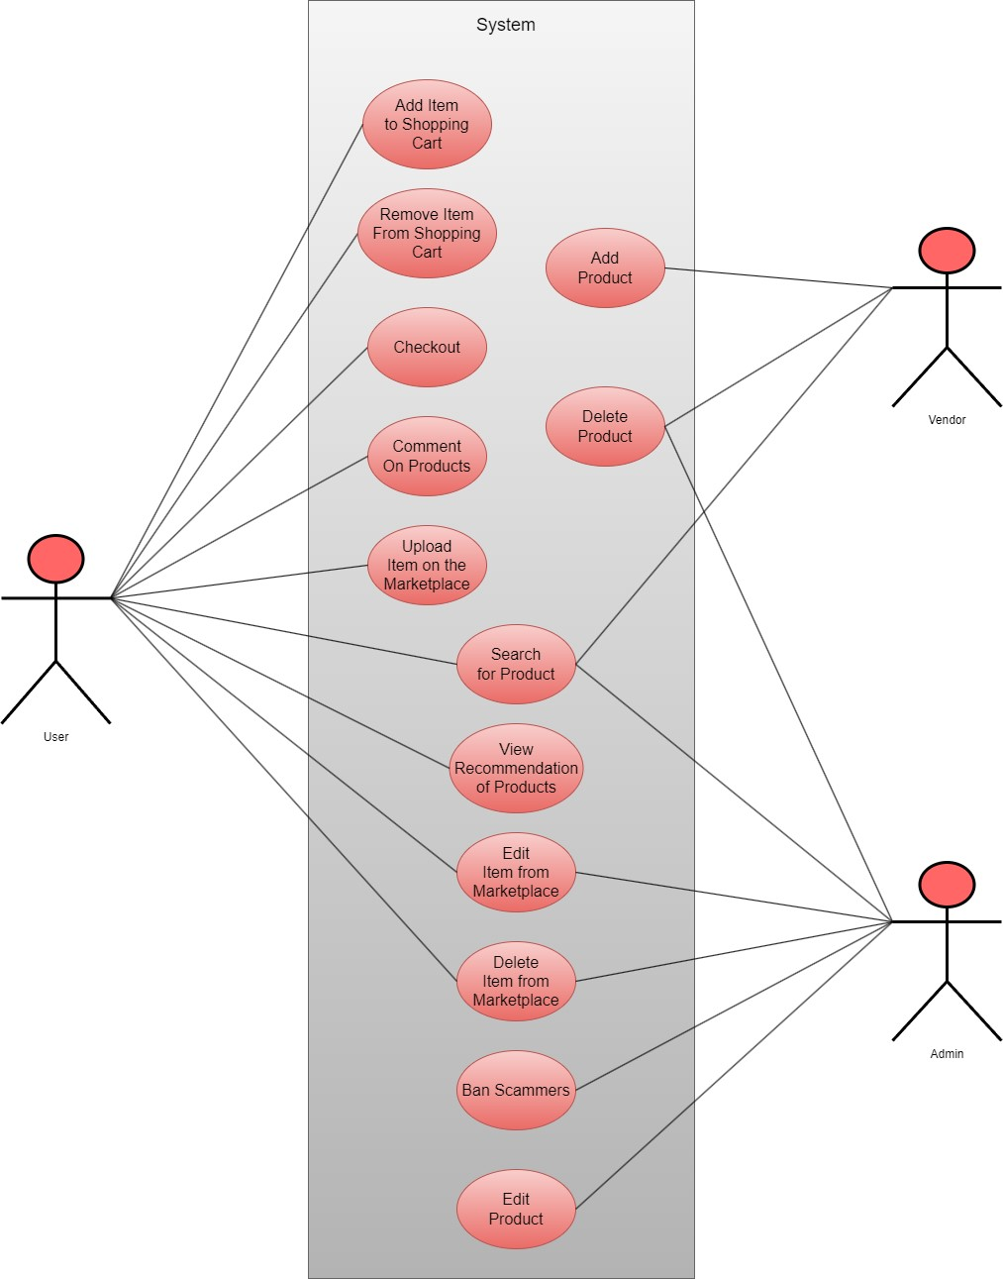

3.4 Sequence Diagram

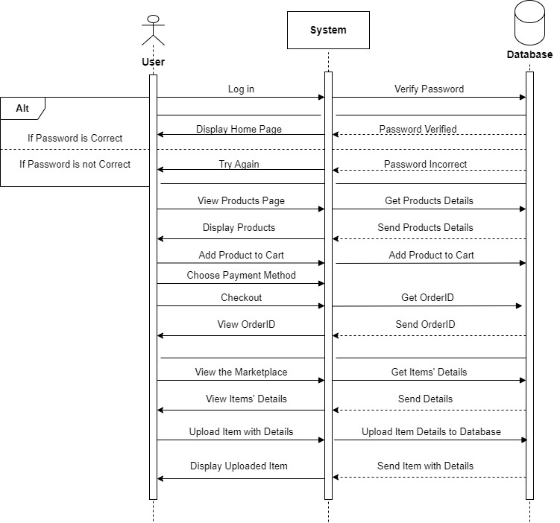

3.5 Activity Diagram

3.5.1 Buying a Product

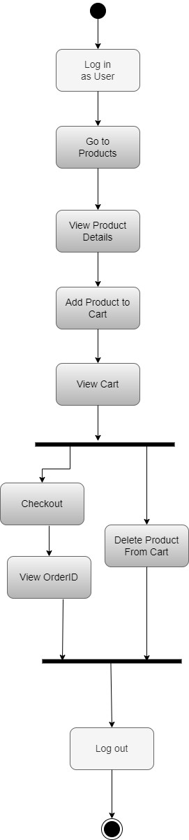

3.5.2 Going through the Marketplace

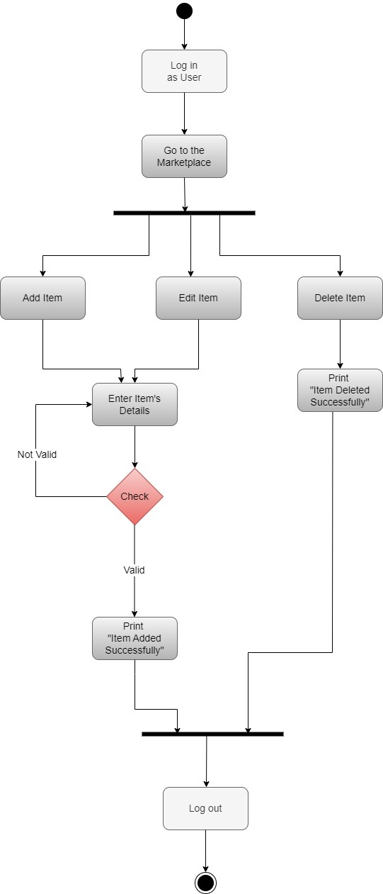

3.5.3 Vendor Dashboard

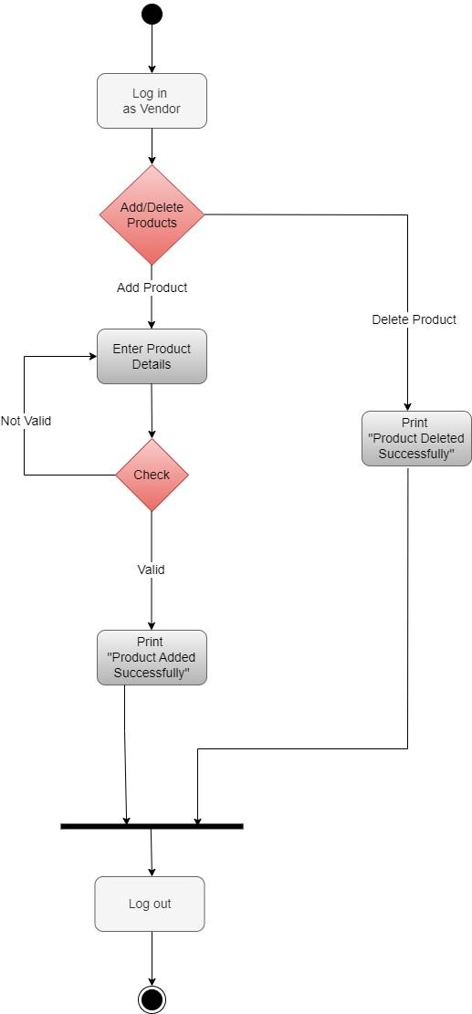

3.5.4 Admin Dashboard

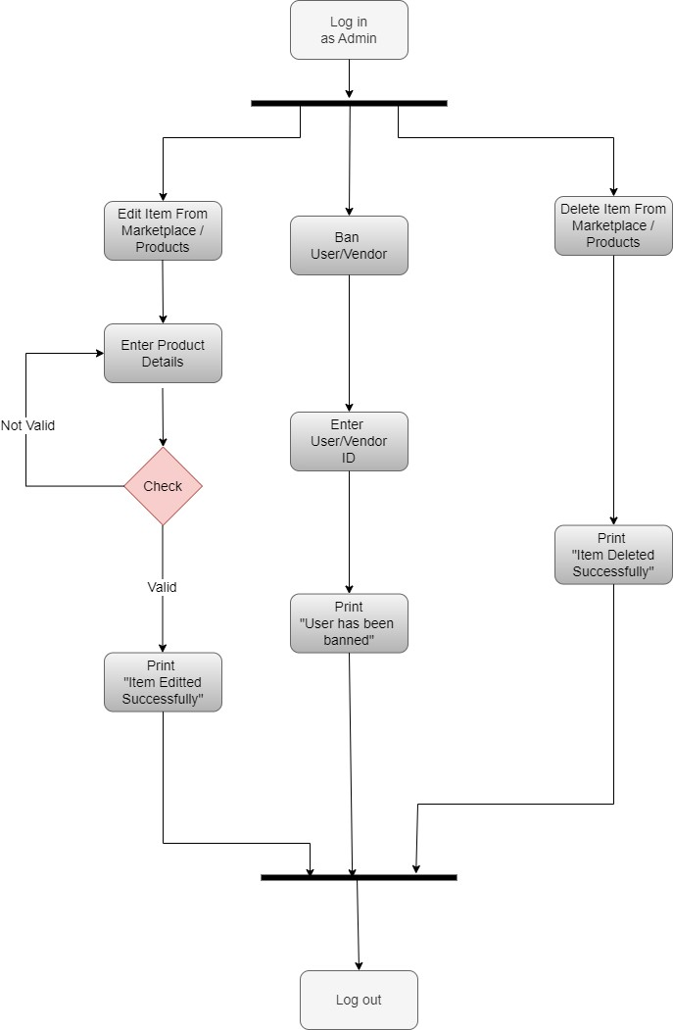

Chapter 4

Implementation

4.1 Client-Side Architecture

The client-side architecture of our Ecommerce website project follows a modern and responsive design using HTML, CSS, and JavaScript. We have utilized the React library to build reusable UI components and manage the state of the application.

Example: UI Components: We have divided the UI components into several modules, such as the Marketplace page, Product Page, user authentication, and the Cart page. Each module consists of reusable React components responsible for rendering specific parts of the user interface and handling user interactions. State Management: To manage the application state, we have integrated Redux, a popular state management library for React. Redux provides a centralized store that holds the application's data and allows components to access and update it.

User Business Logic:

- User Registration



HTTP Request

HTTP Response

Validate the user’s
re
gistration input
data

- User login

_{Generate a JWT}
Token for the authenticated User



Return a response to the client with the JWT token or appropriate error message

Validate the User’s
login data

HTTP Response

HTTP Request POST

Validate the user’s
login input data

- Buying a Product

Add the required product to cart and
chooses the


HTTP Response

HTTP Request POST

Add Product
to Cart

_{Generate Order ID}
payment method
then checks out

for the User

Return with the
Order ID of the transaction

- Add an Item to the Marketplace

Upload the item’s photo and description, also upload the user’s


details such as
Phone and City to
the
item

HTTP Response

HTTP Request POST

Add Item to
Database

_{Return with added}
Item

Return with the added Item

4.2 Server-Side Architecture

1- Programming Languages & Framework:

- Programming Language PHP
- Framework: PHP Laravel

2- Data Access & Storage

- MySQL DB: The SQL Server database is used to store and manage data related to Users, Products, Swap Items, Cart and other relevant information.

3- Authentication & Authorization

- We use the roles that are assigned in the database for authorization which will be user, admin or vendor

- JWT (JSON Web Tokens): JWT is used for issuing and validating tokens for user authentication. When a user successfully logs in, a JWT token is generated and sent to the client, which is then included in subsequent requests for authorization

4- Repository Pattern & Dependency Injection

- Repository Pattern: The repository pattern is implemented to separate data access logic from business logic. It provides a consistent interface for interacting with the data layer.

- Dependency Injection: PHP Laravel’s built-in dependency injection container is used to manage dependencies and inject required services into various components of the application.

Overall Structure of the Server-Side Codebase:

The Server-Side codebase can be structures as follows:

1- API Project: This project contains the API controllers, which handle incoming HTTP requests and return appropriate responses. It exposes endpoints for managing products, cart, user profiles, and authentication.

- Controllers: These classes contain action methods that define the API endpoints and handle the corresponding business logic.
- Models: These classes define the data models used for input and output serialization.

2- Data Access Project: This project focuses on data access and database interactions.
- SQL Server: The SQL Server is responsible for database connectivity and manages the data models and their mappings to database tables.
- Repositories: These classes provide an abstract layer for data access and encapsulate the logic for querying, updating, and deleting data.

3- Authentication Project: This project handles authentication and authorization functionalities.

- Identity Configuration: This includes configuring PHP Laravel Identity to work with JWT tokens, setting up user roles and permissions, and managing user registration and login.

generating and validating JWT tokens based on user - Token Generation: The project includes logic for
credentials.

4.3 Recommendation System (AI Model)

We’ve implemented a ML algorithm which is the Recommendation System where any user tries to buy anything our AI model suggests some products.

The recommendation system is designed in 3 parts based on the business context:
When a new customer without any previous purchase history visits the e-commerce website for the first time, he/she is recommended the most popular products sold on the company's website. Once, he/she makes a purchase, the recommendation system updates and recommends other products based on the purchase history and ratings provided by other users on the website. The latter part is done using collaborative filtering techniques.

Strategy/Techniques used:
- Product popularity based recommendation system targeted at new customers:
Popularity based are a great strategy to target the new customers with the most popular products sold on a business's website and is very useful to cold start a recommendation engine.

- Model-based collaborative filtering system:
Recommend items to users based on purchase history and similarity of ratings provided by other users who bought items to that of a particular customer.

A model based collaborative filtering technique is chosen here as it helps in predicting products for a particular user by identifying patterns based on preferences from multiple user data.

3) Item-item based collaborative filtering system:
For a business without any user-item purchase history, a search engine based recommendation system can be designed for users. The product recommendations can be based on textual clustering analysis given in product description. Predictions done based on other products from the same cluster (based of text analysis of product description) on key search words.

4.4 Pseudocode

Admin Controller
- Function StoreUser(request)
- user := new User()
- user.name := request.name
- user.email := request.email
- user.password := request.password
- user.address := request.address
- user.username := request.username
- user.role := 1
- user.acceptance_flag := 0
- user.suspended_flag := 0
- user.Save()
- return Ok()
- END Function
- Function ShowUser(id)
- user := User.Find(id)
- return user
- END Function
- Function UpdateUser(request, id)
- user := User.Find(id)
- user.name := request.name
- user.email := request.email
- user.password := request.password
- user.address := request.address
- user.username := request.username
- return Ok()
- END Function
- Function DeleteUser(id)
- user := User.Find(id)
- user.Delete()
- return Ok()
- END Function
- Function AddProduct(request)
- result := product_controller.Store(request)
- return Ok()
- END Function
- Function UpdateProduct(request, id)
- result := product_controller.Update(request, id)
- return Ok()
- END Function
- Function DeleteProduct(id)
- result := product_controller.Destroy(id)
- return Ok()
- END Function
- Function BanUser(id)
- user := User.Find(id)
- user.suspended_flag := 1
- user.Save()
- return Ok()
- END Function
- Function AddOffer(request)
- result := offer_controller.Store(request)
- return Ok()
- END Function
- Function UpdateOffer(request, id)
- result := offer_controller.Update(request, id)
- return Ok()
- END Function
- Function DeleteOffer(id)
- result := offer_controller.Destroy(id)
- return Ok()
- END Function
- Function ChangeOfferState(id, state)
- result := offer_controller.ChangeState(id, state)
- return Ok()
- END Function
- Function AddCategory(request)
- result := category_controller.Store(request)
- return Ok()
- END Function
- Function UpdateCategory(request, id)
- result := category_controller.Update(request, id)
- return Ok()
- END Function
- Function DeleteCategory(id)
- result := category_controller.Destroy(id)
- return Ok()
- END Function
- Function AddSubCategory(request)
- result := sub_category_controller.Store(request)
- return Ok()
- END Function
- Function UpdateSubCategory(request, id)
- result := sub_category_controller.Update(request, id)
- return Ok()
- END Function
- Function DeleteSubCategory(id)
- result := sub_category_controller.Destroy(id)
- return Ok()
- END Function

Client Controller
- Function StoreUser(request)
- user := new User()
- user.name := request.name
- user.email := request.email
- user.password := request.password
- user.address := request.address
- user.username := request.username
- user.role := 2
- user.acceptance_flag := 0
- user.suspended_flag := 0
- user.Save()
- return Ok()
- END Function
- Function ShowUser(id)
- user := User.Find(id)
- return user
- END Function
- Function UpdateUser(request, id)
- user := User.Find(id)
- user.name := request.name
- user.email := request.email
- user.password := request.password
- user.address := request.address
- user.username := request.username
- user.Save()
- return Ok()
- END Function
- Function DeleteUser(id)
- user := User.Find(id)
- user.Delete()
- return Ok()
- END Function
- Function MakeOrder(request)
- orderRequest := new Request()
- orderRequest.clientid := request.clientid
- orderRequest.vendorid := request.vendorid
- orderRequest.total := request.total
- last_id := order_controller.Store(orderRequest)
- FOR EACH detail IN request.details
- order_detail_request := new Request()
- order_detail_request.orderid := last_id
- order_detail_request.productid := detail.productid
- order_detail_request.quantity := detail.quantity
- order_detail_request.totalprice := detail.totalprice
- order_detail_controller.Store(order_detail_request)
- END FOR EACH
- return Ok()
- END Function
- Function DeleteOrder(id)
- order_controller.Destroy(id)
- return Ok()
- END Function

Vendor Controller
- Function StoreVendor(request)
- user := new User()
- user.name := request.name
- user.email := request.email
- user.password := request.password
- user.address := request.address
- user.username := request.username
- user.role := 3
- user.acceptance_flag := 0
- user.suspended_flag := 0
- user.Save()
- return Ok()
- END Function
- Function ShowVendor(id)
- user := User.Find(id)
- return user
- END Function
- Function UpdateVendor(request, id)
- user := User.Find(id)
- user.name := request.name
- user.email := request.email
- user.password := request.password
- user.address := request.address
- user.username := request.username
- user.Save()
- return Ok()
- END Function
- Function DeleteVendor(id)
- user := User.Find(id)
- user.Delete()
- return Ok()
- END Function
- Function AddProduct(request)
- product_controller.Store(request)
- return Ok()
- END Function
- Function UpdateProduct(request, id)
- product_controller.Update(request, id)
- return Ok()
- END Function
- Function DeleteProduct(id)
- product_controller.Destroy(id)
- return Ok()
- END Function

Category Controller
- Function StoreCategory(request)
- category := new Category()
- category.catogoryname := request.catogoryname
- category.Save()
- return Ok()
- END Function
- Function ShowCategory(id)
- category := Category.Find(id)
- return category
- END Function
- Function UpdateCategory(request, id)
- category := Category.Find(id)
- category.catogoryname := request.catogoryname
- category.Save()
- return Ok()
- END Function
- Function DeleteCategory(id)
- category := Category.Find(id)
- category.Delete()
- return Ok()
- END Function
- Function GetAllCategories()
- categories := Category.All()
- return categories
- END Function

Sub-Category Controller
- Function StoreSubCategory(request)
- subcategory := new SubCategory()
- subcategory.subcategoryname := request.subcategoryname
- subcategory.categoryid := request.categoryid
- subcategory.Save()
- return Ok()
- END Function
- Function ShowSubCategory(id)
- subcategory := SubCategory.Find(id)
- return subcategory
- END Function
- Function UpdateSubCategory(request, id)
- subcategory := SubCategory.Find(id)
- subcategory.subcategoryname := request.subcategoryname
- subcategory.categoryid := request.categoryid
- subcategory.Save()
- return Ok()
- END Function
- Function DeleteSubCategory(id)
- subcategory := SubCategory.Find(id)
- subcategory.Delete()
- return Ok()
- END Function
- Function GetSubCategoryProducts(id)
- productController := new ProductController()
- return productController.GetBySubCategory(id)
- END Function
- Function GetSubCategories(categoryid)
- subcategories := SubCategory.Where(categoryid = categoryid).Get()
- return subcategories
- END Function

Product Controller
- Function StoreProduct(request)
- product := new Product()
- product.subcategoryid := request.subcategoryid
- product.name := request.name
- product.description := request.description
- product.quantity := request.quantity
- product.price := request.price
- product.Save()
- return Ok()
- END Function
- Function ShowProduct(id)
- product := Product.Find(id)
- return product
- END Function
- Function UpdateProduct(request, id)
- product := Product.Find(id)
- product.subcategoryid := request.subcategoryid
- product.name := request.name
- product.description := request.description
- product.quantity := request.quantity
- product.price := request.price
- product.Save()
- return Ok()
- END Function
- Function DeleteProduct(id)
- product := Product.Find(id)
- product.Delete()
- return Ok()
- END Function
- Function GetAllProducts()
- products := Product.All()
- return products
- END Function
- Function UpdateProductQuantity(request, id)
- product := Product.Find(id)
- product.quantity := request.quantity
- product.Save()
- return Ok()
- END Function
- Function GetProductsBySubcategory(subcategoryid)
- products := Product.Where(subcategoryid = subcategoryid).Get()
- return products
- END Function

Order Controller
- Function StoreOrder(request)
- order := new Order()
- order.clientid := request.clientid
- order.vendorid := request.vendorid
- order.total := request.total
- order.Save()
- return order.id
- END Function
- Function ShowOrder(id)
- order := Order.Find(id)
- return order
- END Function
- Function UpdateOrder(request, id)
- order := Order.Find(id)
- order.clientid := request.clientid
- order.vendorid := request.vendorid
- order.total := request.total
- order.Save()
- return Ok()
- END Function
- Function DeleteOrder(id)
- order := Order.Find(id)
- order.Delete()
- return Ok()
- END Function

Order Details Controller
- Function StoreOrderDetail(request)
- detail := new OrderDetails()
- detail.orderid := request.orderid
- detail.productid := request.productid
- detail.quantity := request.quantity
- detail.totalprice := request.totalprice
- detail.Save()
- UpdateOrderTotal(request.orderid)
- END Function
- Function ShowOrderDetail(id)
- detail := OrderDetails.Find(id)
- return detail
- END Function
- Function UpdateOrderDetail(request, id)
- detail := OrderDetails.Find(id)
- detail.orderid := request.orderid
- detail.productid := request.productid
- detail.quantity := request.quantity
- detail.totalprice := request.totalprice
- detail.Save()
- UpdateOrderTotal(request.orderid)
- END Function
- Function DeleteOrderDetail(id)
- detail := OrderDetails.Find(id)
- orderid := detail.orderid
- detail.Delete()
- UpdateOrderTotal(orderid)
- END Function
- Function UpdateOrderTotal(orderid)
- main_order_details := OrderDetails.Where(orderid)
- total := Sum(main_order_details.totalprice)
- order := Order.Find(orderid)
- order.totalprice := total
- order.Save()
- END Function

Offer Controller
- Function Index()
- roles := Role.FindAll()
- return roles
- END Function
- Function Create()
- // Display the form for creating a new role
- return View('roles.create')
- END Function
- Function StoreRole(request)
- role := new Role()
- role.description := request.description
- role.Save()
- return role.id
- END Function
- Function ShowRole(id)
- role := Role.Find(id)
- return role
- END Function

- Function EditRole(id)
- role := Role.Find(id)
- if role IS NULL THEN
- return Error("Role not found")
- END IF
- return View('roles.edit', { 'role': role })
- END Function
- Function UpdateRole(request, id)
- role := Role.Find(id)
- role.description := request.description
- role.Save()
- return Ok()
- END Function
- Function DeleteRole(id)
- role := Role.Find(id)
- role.Delete() 35. return Ok()
36. END Function

Flowchart
User Authentication:
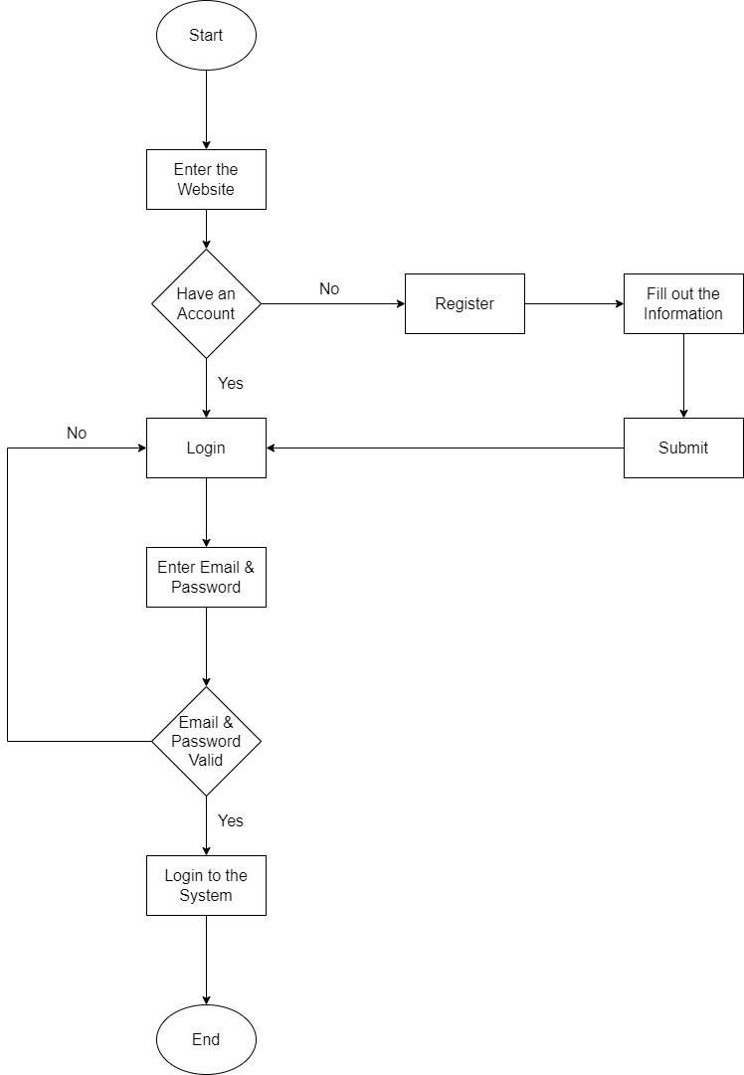

Buying a Product
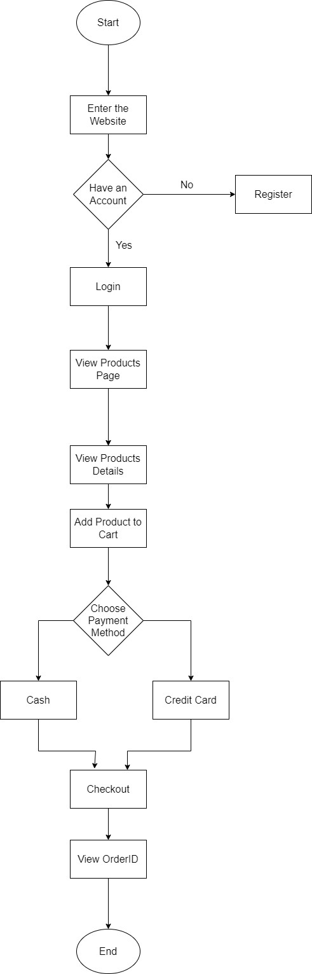

Adding Product to the Marketplace Page

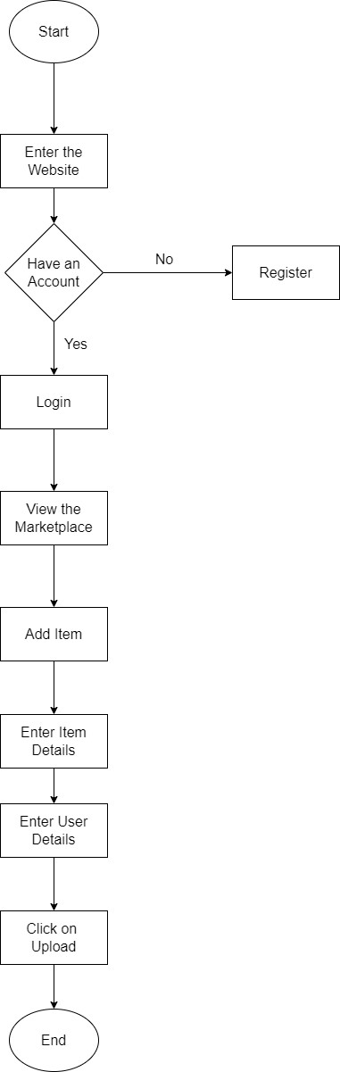

Chapter 5

Testing

5.1 Test Cases

Tesing the Login Funtionality

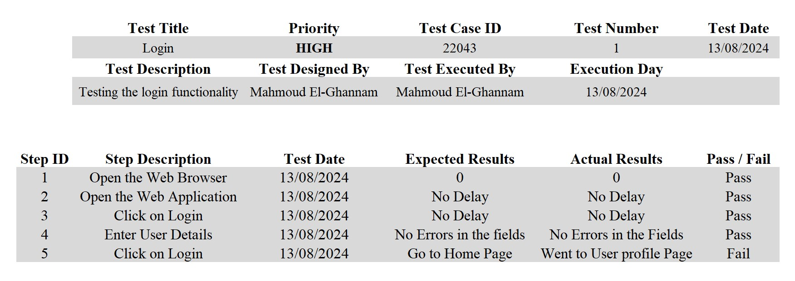

Testing Adding Item to the Marketplace

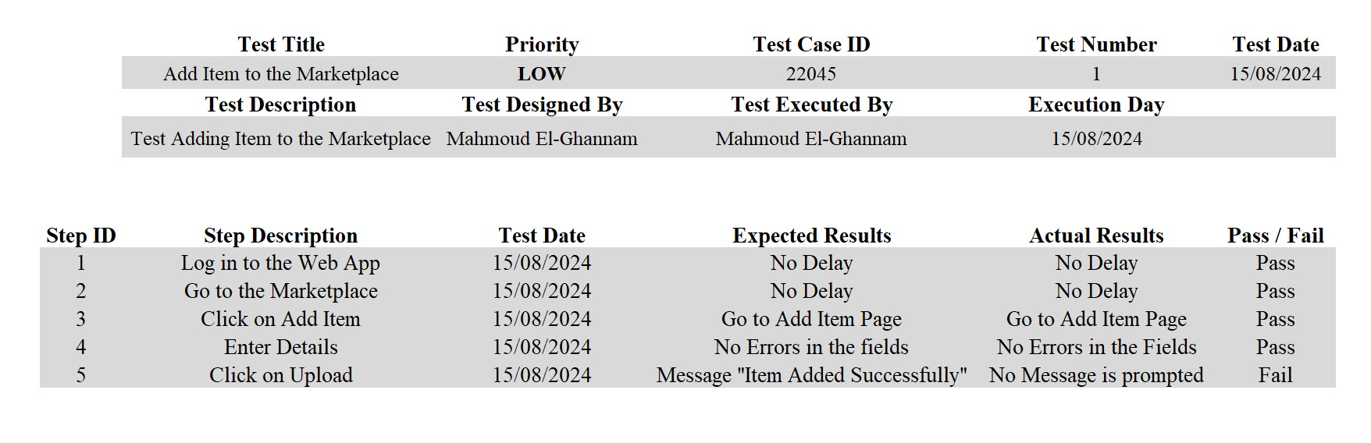

5.2 Bug Reports
Bug Report 1

Bug Summary/Name: Directing User to User profile page after Logging
Bug ID: 023043
Build Number: Version Number 5.0.1
Severity: Low
Priority: High
Assigned to: Mohamed Salah
Reported By: Mahmoud El-Ghannam
Reported On: 13/08/2024
Status: New
Environment: VS Code
Description: After logging User is directed to user profile page instead of home page Steps to Reproduce:
- Open the Web Browser
- Open the Web Application
- Click on Login
- Enter User Details
- Click on Login Button
Expected Results: Go to Home Page
Actual Results: Go to User Profile Page

Bug Report 2

Bug Summary/Name: No message is displayed to User after adding a product on the Marketplace
Bug ID: 023045
Build Number: Version Number 5.0.1
Severity: Low
Priority: Low
Assigned to: Eslam Emad
Reported By: Mahmoud El-Ghannam
Reported On: 15/08/2024
Status: New
Environment: VS Code
Description: After clicking on Upload Item a message should be displayed “Item Added Successfully” Steps to Reproduce:
- Log in to the Web Application
- Go to the Marketplace
- Click on Add Item
- Enter Details
- Click on Upload Button
Expected Results: Message “Item Added Successfully” is displayed to the User
Actual Results: No message is displayed to the User

Chapter 6

Results

6.1 Results
6.1.1 Expected Results:

As we mentioned before our goal is to make a web application that is an ecommerce application where Users can find their needed products, put them into Cart and proceed to Checkout so the order can be delivered to them, also we want there to be a so that users can post items they have for sale or to be swapped on the site and for the Vendors role is to put products on the Products page and for the Admin is to edit/delete any products on the Products page or any items on the Marketplace that do not agree with our standards and policy in Egypt

6.1.2 Actual Results . Screens of the Web App:
- Sign Up Page:
This the Sign up Page where users can create their accounts and start using our web application first they need to enter their e-mail

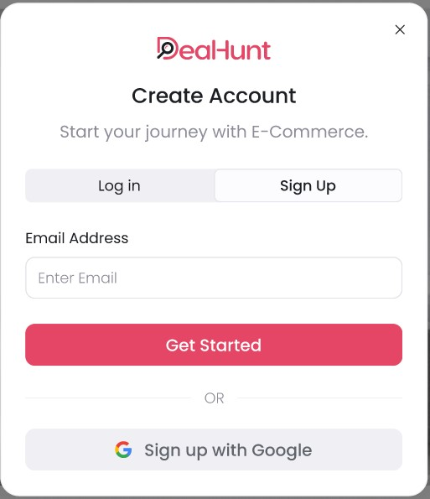
And here is the second step of Sign Up the User needs to enter and confirm their password

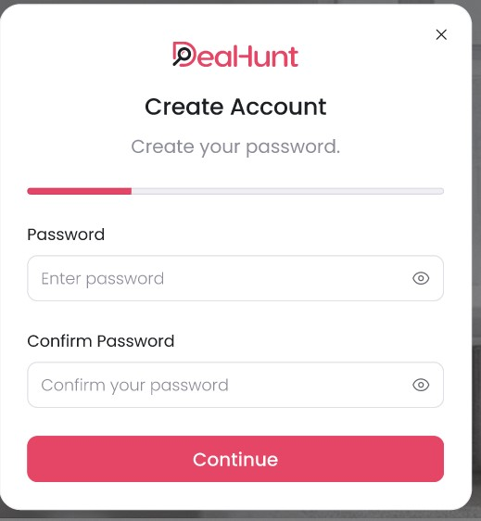

And this is the last step of our Sign Up Process where the User enter their First and Last Names, phone number and chooses a governorate, also they have to accept our privacy policy standards and can check the box if their number supports Whatsapp

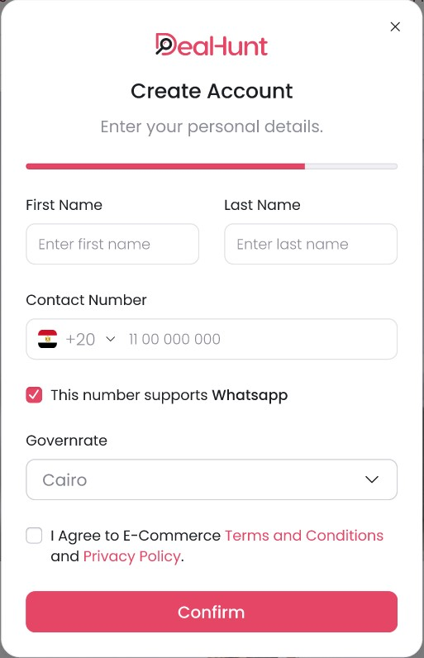
- Login Page:
Here Users can log in with their credentials Email and
Password, there is also an option to sign in with Google and if a User forgot their password they can choose the option “Forgot Password” so that they can easily reset their Password

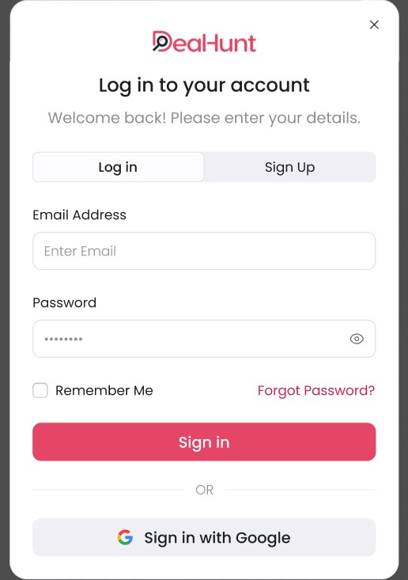

- Home Page:
This is the Home page of our web application where users can view products on the products page, view the marketplace and post items for sale or to be swapped

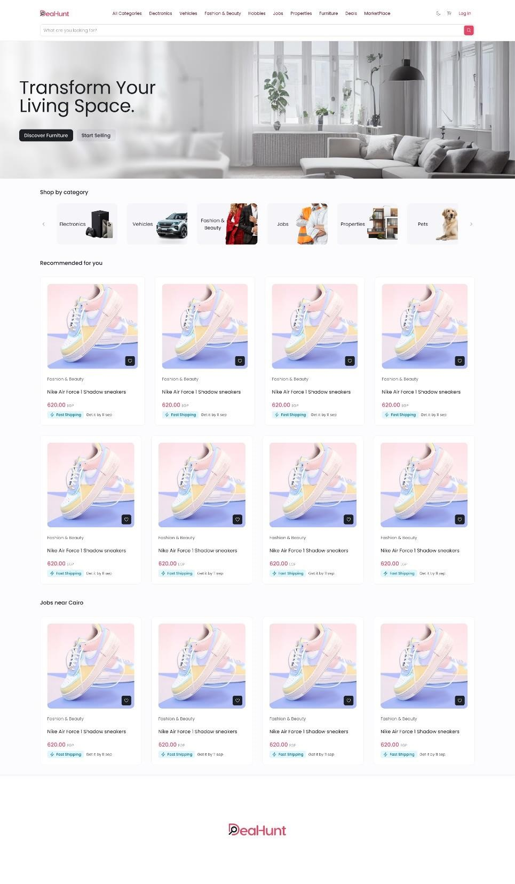
- Products Page:
This is the Products page where the Products are displayed to Users with their categories and prices the User can then click on any Product to view it description and details and can add it to Cart

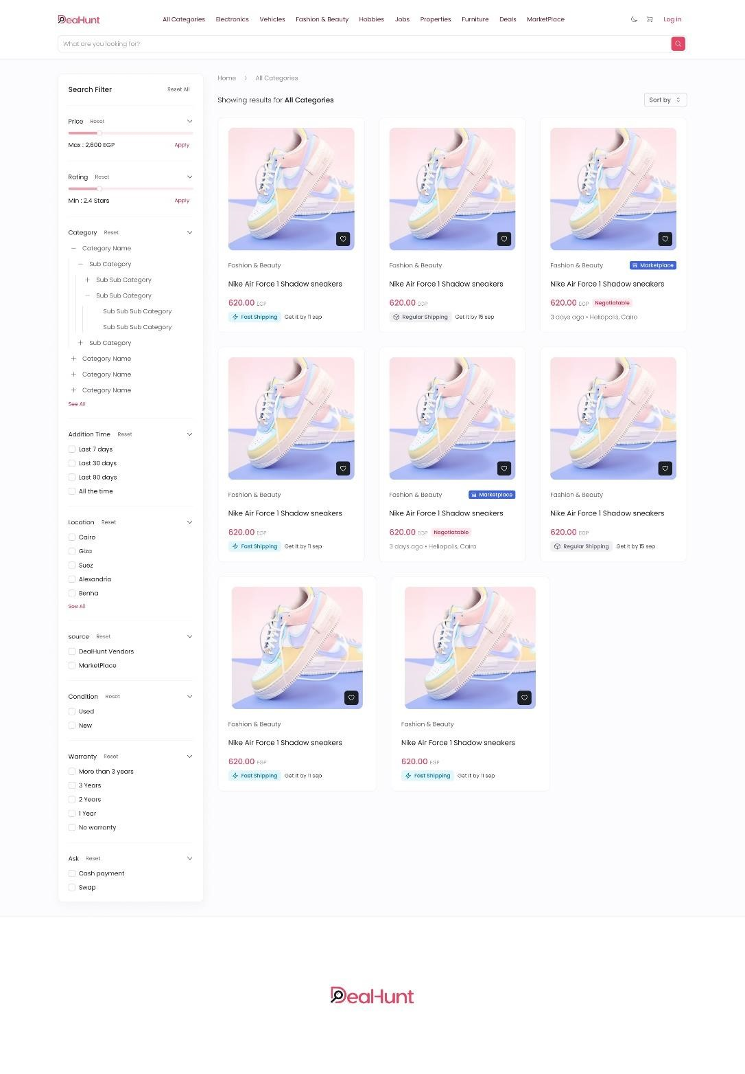
Here is the Product Details page as mentioned earlier

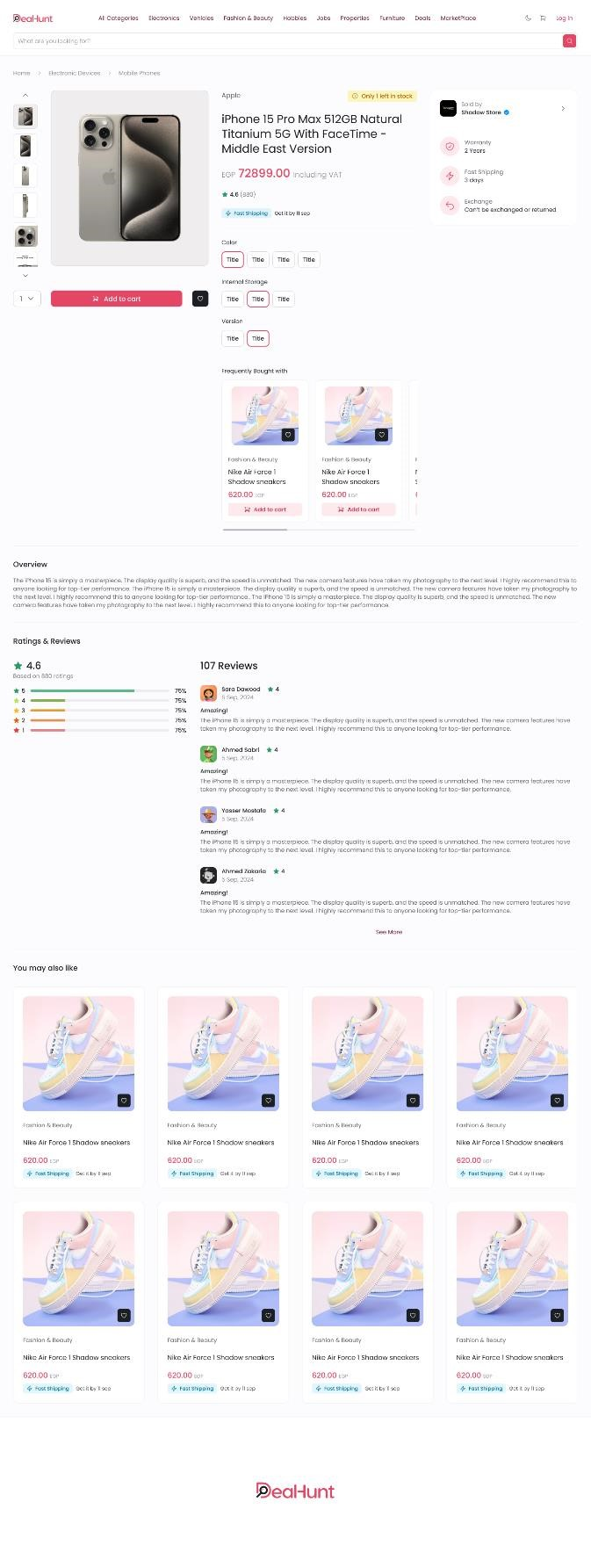

- Cart Page:
This is the Cart page when the User adds their item to the cart so that they can checkout after

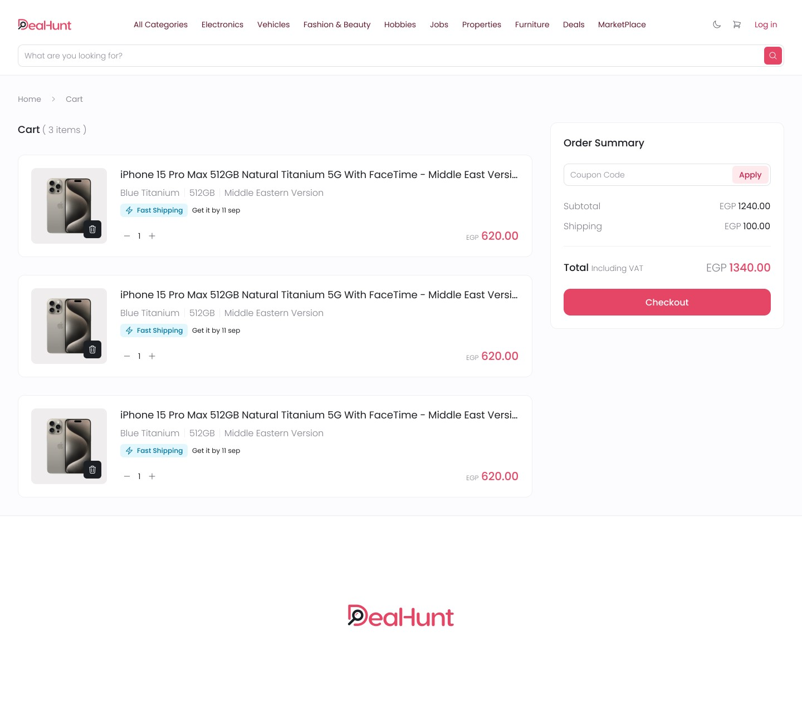

- Checkout Page:
This is the Checkout page where the user confirms his order, quantity and confirms his address so that the order can be delivered to them
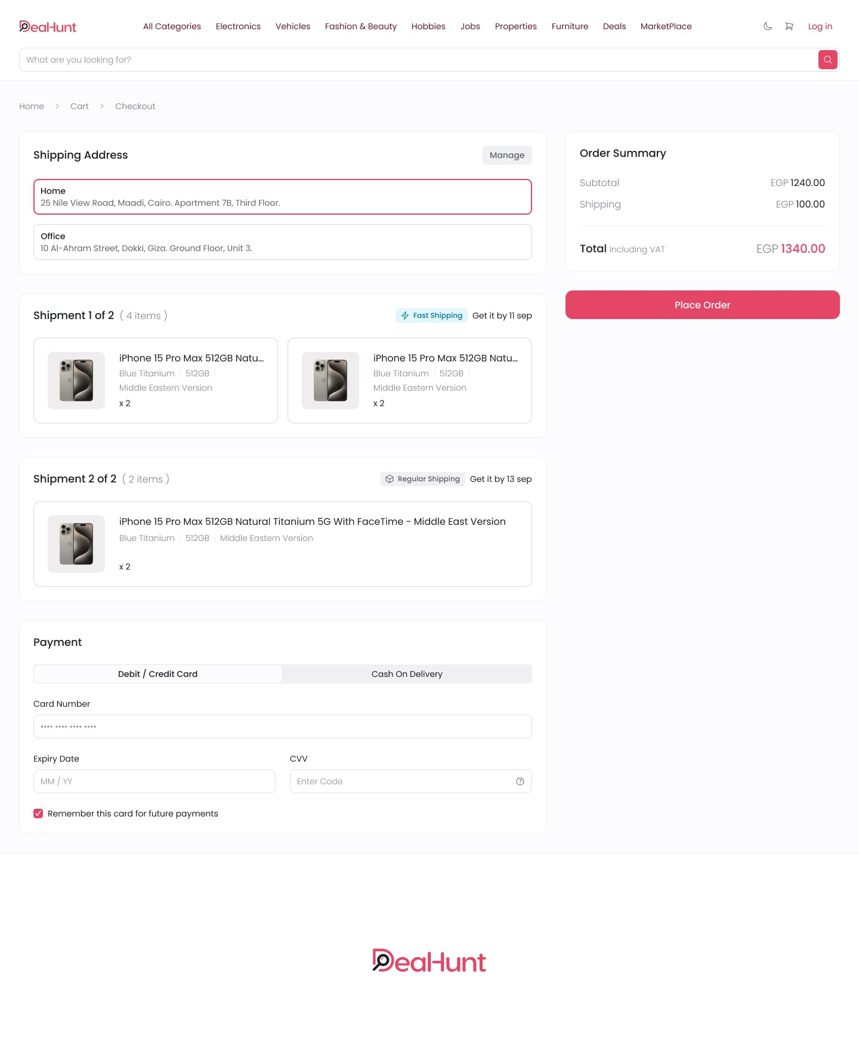
- Marketplace Page:
This is the Marketplace page where users can upload the Items they want to sell on the web app with their description and price or the item they wish to swap with, also they can edit/delete their Items and view other Users’ Items

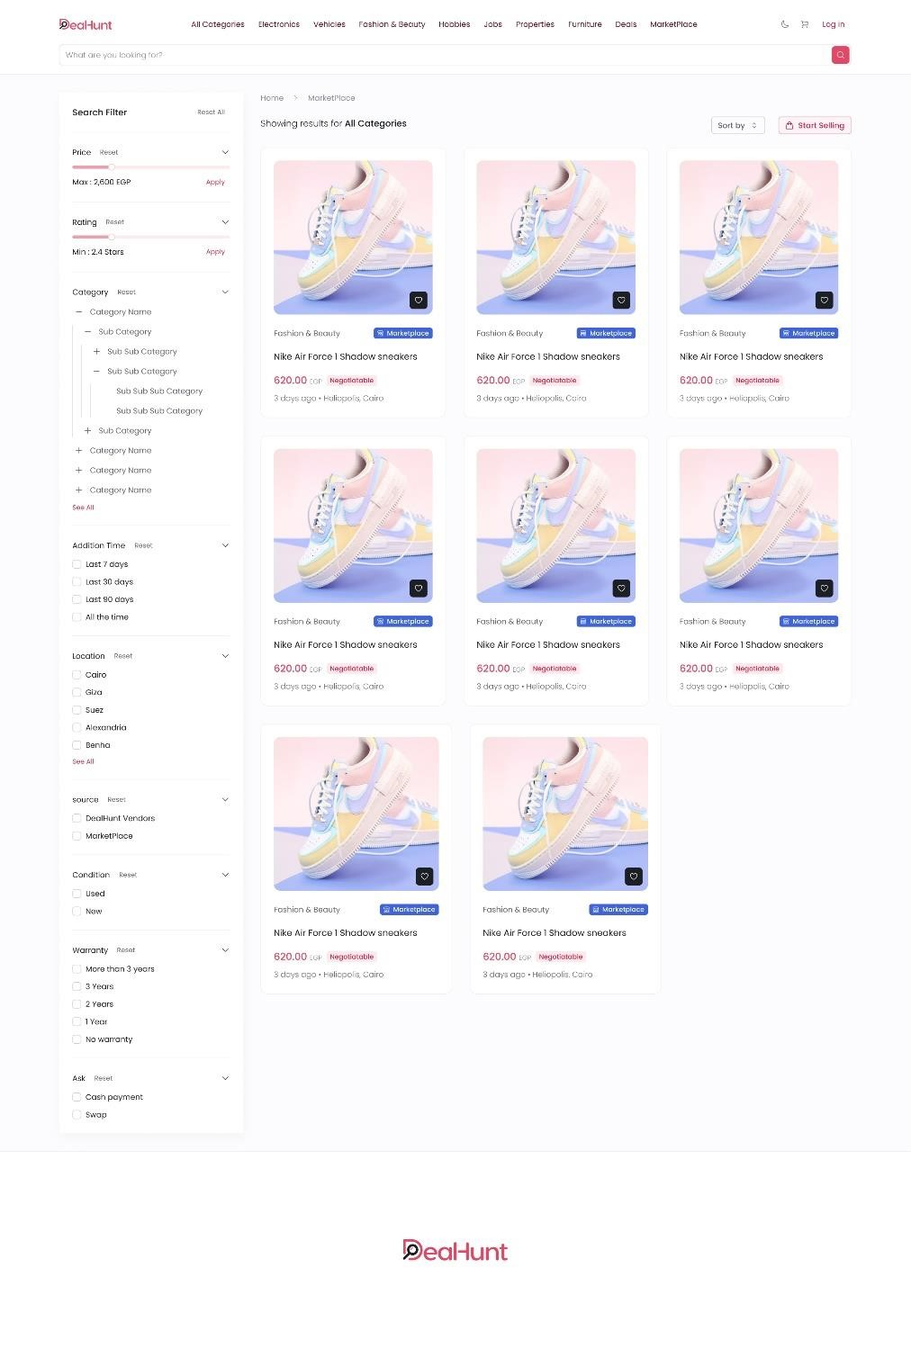

8- Uploading Item on the Marketplace
This page enables users to upload their items on the Marketplace so that they can be swapped for money or another item by entering data in the specified fields such as name, description, image and what item it should be swapped with along with the location of the seller with their personal info like name and phone number
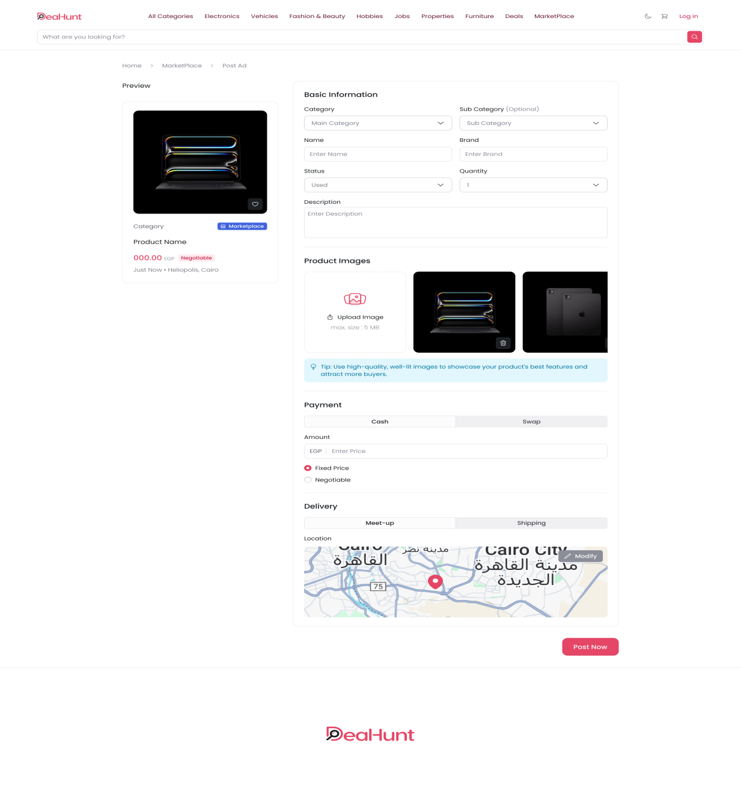

Chapter 7

Future Work

Future Work

In the future, we aim to continuously enhance the Alumni
Portal system to provide a more advanced and scalable
platform for university graduates. The goal is to improve system capabilities, expand its reach, and introduce new intelligent features that better support alumni interaction and
engagement.
One of the main planned improvements is the integration of artificial intelligence for multimedia content analysis. This will include AI-based image analysis to detect inappropriate or harmful content shared by users, ensuring a safer and higher-quality environment within the platform. In addition, we plan
to extend this capability to video content, allowing alumni to
upload videos while enabling AI-driven video analysis to
monitor and filter content effectively.
Furthermore, we aim to enhance user interaction by adding a new feature that allows graduates to share videos directly
on the platform, which will enrich communication and
increase engagement between users. We also plan to introduce
a post-sharing feature, enabling users to share posts within the platform, which will help increase content reach and improve interaction among alumni.
In addition, we plan to expand the system to become a multi-university platform, allowing graduates from different
universities to join the same ecosystem. This will help build a stronger professional network, increase knowledge sharing,
and create a larger community for exchanging experiences and opportunities across different academic institutions.
We also aim to improve the system by developing a mobile application version for both Android and iOS, making the platform more accessible and user-friendly anytime and anywhere.
Finally, future updates may include enhanced recommendation systems and smarter community-based engagement tools to further improve interaction between alumni. We will also continue to focus on system scalability, performance improvement, and data security to ensure that users’ personal information and interactions remain fully protected while maintaining a reliable and efficient platform.

Bibliography:

- React.js (Frontend Development):
https://reactjs.org/docs/getting-started.html

- Node.js (Backend Runtime Environment):
https://nodejs.org/en/docs

- Express.js (Backend Framework):
https://expressjs.com/

- PostgreSQL Database:
https://www.postgresql.org/docs/

- Cohere AI (AI Moderation & Content Analysis for Images, Posts, and Videos):
https://cohere.com/docs

- Postman (API Testing and Development):
https://learning.postman.com/

- Git & GitHub (Version Control System):
https://git-scm.com/doc
https://docs.github.com/

- Visual Studio Code (Development Environment):
https://code.visualstudio.com/docs

- Draw.io (System Design & Diagrams):
https://app.diagrams.net

- StarUML (UML Diagrams):
https://staruml.io

